

AI-powered Resume Screening and Ranking System

A Project Report
submitted in partial fulfillment of the requirements of
AICTE Internship on AI: Transformative Learning with
TechSaksham – A joint CSR initiative of Microsoft & SAP

By

Rangam Bharath
bharathkumar219143@gmail.com

Under the Guidance of
Prof. Soumya Chaudhary



ACKNOWLEDGEMENT

This would be an opportunity to convey my profound appreciation for all the people who directly or indirectly contributed to the successful completion of this project. To begin with, I would like to express my heartfelt gratitude to my supervisor, Prof. Soumya, for being more than just a teacher: an exceptional mentor and guide of this project. No amount of thankfulness can truly convey my respect towards him: for his valuable insights, his steady encouragement through thick and thin, and constructive feedback over and above all else. The belief he had in me continued to boost my morale while I dared to experiment with new ideas and improve my approach. Under his guidance, I had a truly enhancing experience; his collective support and faith superintended the successful execution of this project by helping out in countless ways. Furthermore, I wish to express sincere appreciation to all of my faculty members, friends, and family for their unending assistance, motivation, and guidance through this long journey. Their continued encouragement was invaluable in surmounting hurdles and uplifting the work I've done. Last but not least, I would like to acknowledge the many online resources, tools, and platforms that offered me the knowledge and technical support to carry out this project efficiently. It has been a great learning experience for me throughout this project, and I am grateful for everyone involved in making it a success.



ABSTRACT

The evolving technology is creating many chances of employment for many. Nowadays to apply for any job the most essential document is a resume tells a lot about the person's achievements and the skills in all walk of life. The person applying for the job highlights the strong points and skill sets required for the company. Multinational organizations receive thousands of emails from such people who send their resumes for them to apply for a certain post. Now the real challenge is to know which resumes is to be stored and shortlisted according to the constraints. One method is to manually check and sort the resume. Now, this method is the most time-consuming and also can lead to a lot of errors because of human interventions. Also, humans cannot keep on working continuously. Hence there is a problem of less efficiency as well. Thus, we have proposed a system that will easily find the required skill set by scanning the document or the to the skill sets which is a specified constraint of the organization. We are going to use the concept of Machine learning. Machine learning for recruiting is an emerging category of HR technology designed to reduce or even remove time-consuming activities like manually screening resumes.



TABLE OF CONTENT
Abstract I
Chapter 1. Introduction 1
  - Problem Statement 1
  - Motivation 1
  - Objectives 2
  - Scope of the Project 3
Chapter 2. Literature Survey 5
Chapter 3. Proposed Methodology 9
Chapter 4. Implementation and Results 14
Chapter 5. Discussion and Conclusion 17
References 19



LIST OF FIGURES

Figure No. | Figure Caption | Page No.
Figure 1 | System Architecture | 9
Figure 2 | Use-Case Diagram | 10
Figure 3 | Activity Diagram | 11
Figure 4 | Sequence Diagram | 12
Figure 5 | Creating a Position for a Candidate | 14
Figure 6 | Uploading the resumes | 13
Figure 7 | Matching the candidates for AI Engineer | 15
Figure 8 | Analyzing the eligibility criteria in different aspects | 16



CHAPTER 1 INTRODUCTION

PROBLEM STATEMENT
Day by day there are so many new researches that are being carried out by so many organizations in many fields. Right from the IT sector to the Medical fields, there are so many researches as well are progress made in day to day life. These progress in these fields are creating new employment opportunities all over the world. Now we know that the hiring process across the world is the same. That is the candidate has to make the resume first and as most of the recruitment process is based on the candidates' resume. Now most of the organizations tell the candidates to send the resume via e-mails. Now after they receive the email the next job is to sort them according to the requirement. Now usually they sort these manually but this process is time consuming. Also there may be so many errors due to that. The efficiency of such sorting is extremely low. this may result in giving a chance to a candidate whose credentials are not up to the mark for the organization or this may also make the manual sorting miss the candidate who is extremely good for the organization. Hence a system which is intelligent enough to sort all these documents without any error and within time is needed which is exactly our aim. machine learning for recruiting is the application of machine learning, such as the learning or problem-solving that a computer can do, to the recruitment function. This new technology is designed to streamline or automate some part of the recruiting workflow, especially repetitive, high-volume tasks. For example, software that applies machine learning to resumes to auto-screen candidates or software that conducts sentiment analysis on job descriptions to identify potentially biased language.

MOTIVATION
Recruitment is a 200-billion-dollar business. It deals with hiring the best-fit candidates having the relevant skills for a given job profile from an immensely large pool of candidates. If a company has any job opening for a position, scores of candidates mail their resumes to the company to apply for that opening. In the hiring process, the first task for any recruiter is to screen the resumes of all the job applicants. Any company having a job opening for a particular position will have their mail inboxes bombarded with thousands of emails from aspiring job applicants every single day. Selecting the prospective candidates for that job position from a large pool of candidates for any recruiter is very tedious. It is an extremely daunting task for the recruiters of a company to manually go through thousands of resumes and select the most appropriate candidates for the job. Out of those thousands of resumes submitted to the company for the given job posting, about 75% of them do not showcase the relevant skills that are required for the job profile.



Due to this, the recruiters quite often find it really arduous to narrow down the most appropriate candidates from a large applicant pool. In recent years, there have been more than 50,000 e-recruitment sites have been developed. The developers of these online recruitment sites have used various approaches to identify the prospective candidates for a given job profile of a company. Some of these, have managed to employ classification techniques that will classify the candidate resumes into various categories for every job posting given by every company. In these approaches, every candidate's resume is tried to match with every given job posting on the recruitment site. The aim of these recruitment sites is to throw up the results to the candidate to which they are the best fit. The techniques used by these sites have resulted in high accuracy and precision, but one of the major disadvantages is the factor of time complexity. If every candidate's resume is matched with every other job posting given on the online recruitment site, the time complexity for acquiring the results is very high.
The world of Artificial Intelligence [Al] and Machine Learning [ML] has grown significantly in recent times. The availability of large amounts of data brought about by advancements in technology which has made the internet cheap and accessible to previously inaccessible regions of the world has contributed to a great increase in the performance of the ML models in recent times. Software companies around the world exploit the advances in ML to drive automation and increase their productivity in areas that relied mostly on manual human labor. The approach discussed in this project is by using machine learning to train the dataset for a particular type of job position. It is also proposed to use section-based segmentation for data extraction using Natural language Processing (NLP). In order to improve the time efficiency of the web application, the candidate's resume will only be matched to those job openings where they are interested in and have applied to which will, in turn, reduce the time complexity. Besides, the results of the resume matching of all the candidates who have applied for the job opening will be visible only to the recruiter of that particular company. This is done with the aim to aid the recruiters of any company from the long and tedious task of viewing and analyzing thousands of candidates' resumes. In this intelligent-based approach, they will be given the option to view the candidate's resume as well as they will get the results of the best candidates suitable for the required job position. same disease, we use it as the score to rank the similarity among patients.

OBJECTIVE
    - The major objective of our system is to take the current resume ranking system to another level and makes it more flexible for both the entity.
- Candidates, who have been hired.
- Client company, who is hiring the candidates



  - To propose an algorithm that provides a list of applicants with appropriate experience and then presents the high points of each selected resume, unlike the conventional way of applying filters and manually scanning resumes.
  - To identify the most qualified candidates for a certain vacancy.
  - To automate tasks that the human resources can do and recognize and identify human faces
  - It proposes a resume ranking software that uses natural language processing (NLP) and machine learning.
  - It could be used in MNCs where multiple resumes must be screened every single day for multiple jobs, government, and administrative offices.
  - If an organization gets the right candidates in place in the company, human resources can focus their efforts on building a driven company culture, and onboarding the right human capital for the positions that come up.

SCOPE OF THE PROJECT SCOPE
- Efficiency: These systems can process large volumes of resumes quickly, significantly reducing the time spent on initial candidate evaluations.
- Keyword Matching: AI tools utilize algorithms to identify relevant keywords and phrases that align with job descriptions, helping to filter candidates based on specific qualifications.
- Bias Reduction: Ideally, AI systems can minimize human biases by focusing solely on qualifications and skills, potentially leading to a more diverse candidate pool.
- Continuous Learning: Many AI systems improve over time as they learn from past hiring decisions, enhancing their ability to identify suitable candidates.
- Integration with ATS: AI-powered tools often integrate with Applicant Tracking Systems (ATS), streamlining the recruitment process from application to interview.

LIMITATIONS
- Bias in Algorithms: If the training data contains biases, the AI may inadvertently perpetuate these biases, leading to unfair candidate evaluations.
- Over-Reliance on Keywords: These systems may overlook qualified candidates who do not use the exact keywords or phrases that the AI is programmed to recognize.
- Inability to Assess Soft Skills: AI tools struggle to evaluate intangible qualities such as communication skills, cultural fit, and emotional intelligence, which are crucial for many roles.



- Contextual Understanding: AI lacks the ability to understand the deeper context of a candidate's experience, values, or potential, which can lead to misinterpretations of qualifications.
- Non-Traditional Candidates: The technology may not effectively assess candidates with unconventional backgrounds or career paths, potentially missing out on unique talents.
- Dependence on Data Quality: The effectiveness of AI systems is heavily reliant on the quality and comprehensiveness of the data they are trained on; poor data can lead to inaccurate assessments.



CHAPTER 2 LITERATURE SURVEY

  - Review of relevant literature or previous work in this domain. TITLE 1: Resume Classification And Ranking Using KNN And Cosine Similarity AUTHORS: Rajath V; Riza TanazFareed; SharadadeviKaganurmath DESCRIPTION:
The authors in [1] created an automated machine learning-based algorithm that recommends acceptable applicant resumes to HR based on the job description provided. The suggested methodology had two stages: first, it classified resumes into various groups. Second, it suggests resumes based on their resemblance to the job description. If an industry produces a high number of resumes, the proposed approach can be used to create an industry-specific model.

TITLE 2: Natural Language Processing based Jaro-The Interviewing Chatbot
AUTHORS: Jitendra Purohit; Aditya Bagwe; Rishabh Mehta; Ojaswini Mangaonkar; Elizabeth George

DESCRIPTION:
The proposed system, JARO accelerates the interview process towards an unbiased decision-making process by proposing a chatbot that would conduct interviews by analyzing the candidate's Curriculum Vitae (CV), based on which, it then prepares a set of questions to be asked to the candidate. The system will consist of features like resume analysis and automatic interview processes.

TITLE 3: Design and Development of Machine Learning based Resume Ranking System
AUTHORS: Tejaswini K; Umadevi V; Shashank M Kadiwal; Sanjay Revann
DESCRIPTION: The top applicants might be rated using content-based suggestion, which uses cosine similarity to find the curriculum vitae that are the most comparable to the job description supplied and KNN algorithm is used to pick and rank Curriculum Vitaes (CV) based on job descriptions in huge quantities.



TITLE 4: A Machine Learning approach for automation of Resume Recommendation system
AUTHORS: Pradeep Kumar Roy; Sarabjeet Singh Chowdhary; Rocky Bhatia
DESCRIPTION: Suggested that an automated way of "Resume Classification and Matching" could really ease the tedious process of fair screening and shortlisting, it would certainly expedite the candidate selection and decisionmaking process. This system could work with a large number of resumes for first classifying the right categories using different classifier, once classification has been done then as per the job description, top candidates could be ranked using Content-based Recommendation, using cosine similarity and by using k-NN to identify the CVs that are nearest to the provided job description.

TITLE 5: A Hybrid Approach to Conceptual Classification and Ranking of Resumes and Their Corresponding Job Post
AUTHORS: AbeerZaroor; Mohammed Maree; Muath Sabha
DESCRIPTION: The research work of authors in [7] presented a hybrid approach that employs conceptual-based classification of resumes and job postings and automatically ranks candidate resumes (that fall under each category) to their corresponding job offers. In this context, the exploit an integrated knowledge base for carrying out the classification task and experimentally demonstrate using a real-world recruitment dataset achieving promising precision results compared to conventional machine learning-based resume classification approaches.

TITLE 6: An Empirical Study of Artificial Intelligence and its Impact on Human Resource Functions
AUTHORS: Garima Bhardwaj; S. Vikram Singh; Vinay Kumar
DESCRIPTION: The study work in [8] was conducted among 115 HR professionals at various IT sectors in Delhi/NCR region. A multiple regression method was used to test the hypothesis and confirmed a positive relationship between these two factors establishing about the increased use of Al at work results in better HR functional performance.
However, Al has a significant relationship with innovativeness and also with the ease of use which reflects Al affects HR with innovations and ease of use.

TITLE 7: Intelligent Recruitment System Using NLP
AUTHORS: Anushka Sharma; Smiti Singhal; Dhara Ajudia



DESCRIPTION: The research work in [9] focuses on extracting data from resumes and performing the required analysis on the data to convert it into useful information for the recruiters. Thus, the Resume Parser would help the recruiters to select the best relevant candidates in a minimal amount of time, consequently saving their time and effort.
TITLE 8: ResumeNet: A Learning-Based Framework for Automatic Resume Quality Assessment
AUTHORS: Yong Luo; Huaizheng Zhang; Yongjie Wang; Yonggang Wen; Xinwen Zhang
DESCRIPTION: The authors in [10] developed a method for automatic RQA. Since there is also no public dataset for model training and evaluation, we build a dataset for RQA by collecting around 10K resumes, which are provided by a private resume management company. By investigating the dataset, we identify some factors or features that could be useful to discriminate good resumes from bad ones, e.g., the consistency between different parts of a resume.

TITLE 9: Ethical Considerations in Al-Based Recruitment.
AUTHORS: Mujtaba, Dena F., and Nihar R. Mahapatra
DESCRIPTION: Presents an overview of fairness definitions, methods, and tools as they relate to recruitment and establishes ethical considerations in the use of machine learning in the hiring space. Considering Deep Learning (DL) method recognize artificial Neural Network (NN) to nonlinear process, NLP tools become increasingly accurate and efficient that begin a debacle. Multi-Layer Neural Network obtaining the importance of the NLP for its capability including standard speed and resolute output. Hierarchical designs of data operate recurring processing layers to learn and with this arrangement of DL methods manage several practices.

TITLE 10: Inflectional review of deep learning on natural language processing.
AUTHORS: Fahad, SK Ahmed, and Abdul Samad Ebrahim Yahya
DESCRIPTION: This resumed striving to reach a review of the tools and the necessary methodology to present a clear understanding of the association of NLP and DL for truly understanding in the training. Efficiency and execution both are improved in NLP by Part of speech tagging (POST), Morphological Analysis, Named Entity Recognition (NER), Semantic Role Labeling (SRL), Syntactic Parsing, and Coreference resolution. Artificial Neural Networks (ANN), Recurrent Neural Network (RNN), Convolution Neural Networks (CNN), dealings among Dense Vector (DV), Windows Approach (WA), and Multitask learning (MTL) as a characteristic of Deep Learning.



EXISTING SYSTEM
The existing system is a traditional Machine Learning based system. It gives lower rates of accuracy. It has lower efficiency. It gives lower inaccurate results. This system may lead to loss of human potential.

EXISTING SYSTEM DRAWBACKS
- Costs can spiral
- It can be difficult to measure their effectiveness
- It's informal
- It attracts bad candidates
- There's a lot of competition
- It could lead to lost labour hours
- It attracts fraudulent applicants
- It can affect communication

METHODOLOGY
Data Collection: Collect a dataset of resumes and job requirements for different job positions.
Data Preprocessing: Preprocess the dataset by cleaning the text data, removing stop words, stemming, and lemmatization.
Keyword Extraction: Use NLP techniques such as bag-of-words and TF-IDF to extract relevant keywords from the job requirements and resumes.
Classification: Use ML classification algorithms such as SVM, Naive Bayes, and Decision Trees to classify resumes into different categories based on job requirements. Train the classification model using a set of labeled data.
Ranking: Use ML ranking algorithms such as PageRank and HITS to rank the resumes based on their relevance to the job requirements. Train the ranking model using a set of labeled data.
Clustering: Use ML clustering algorithms such as k-means clustering and hierarchical clustering to group similar resumes together.
Evaluation: Evaluate the performance of the system using metrics such as accuracy, precision, and recall. Fine-tune the system by adjusting the parameters of the algorithms and testing the performance.



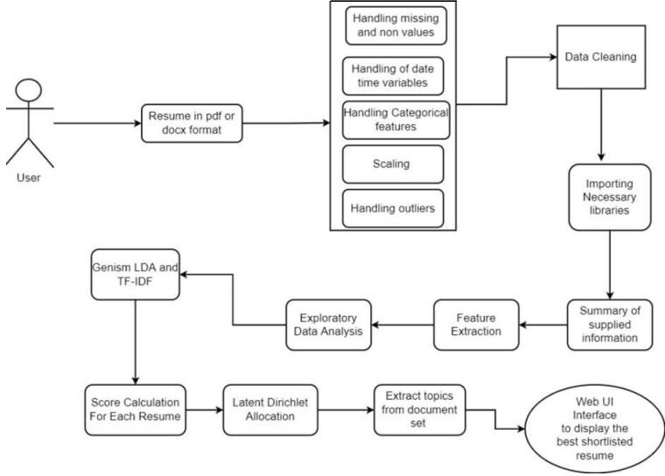
CHAPTER 3 PROPOSED METHODOLOGY

SYSTEM DESIGN

    - SYSTEM ARCHITECTURE

This diagram is nothing but a simple description of all the entities that have been incorporated into the system. The diagram represents the relations between each of them and involves a sequence of decision-making processes and steps. You can simply call it a visual or the whole process and its implementation. All functional correspondences are explained in this diagram.

Figure 1: System Architecture



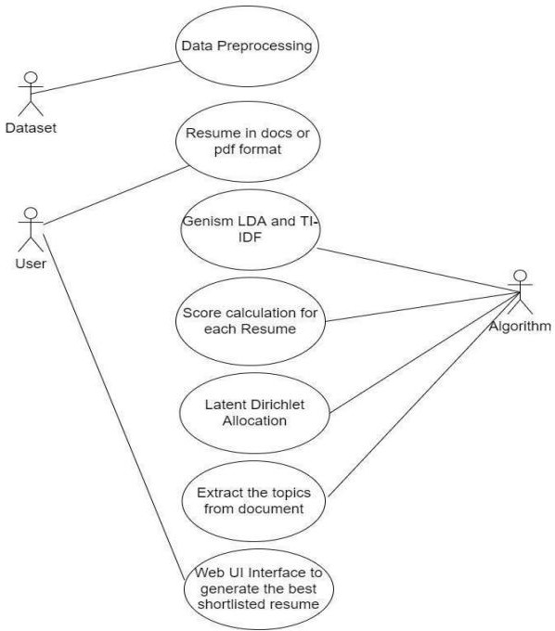
USE-CASE DIAGRAM

A use case diagram is a standard diagram that shows all interactions between the user, dataset, and algorithm used. It is developed in the early stages of the process.

Figure 2 : Use-Case Diagram



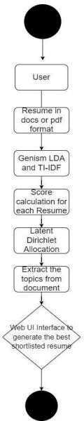
ACTIVITY DIAGRAM
In simple terms, a diagram that represents the order of all activities is called the activity diagram. It shows the workflow between different activities that take place in the whole process. However, these are not exactly flowcharts but are similar.

Figure 3 : Activity Diagram



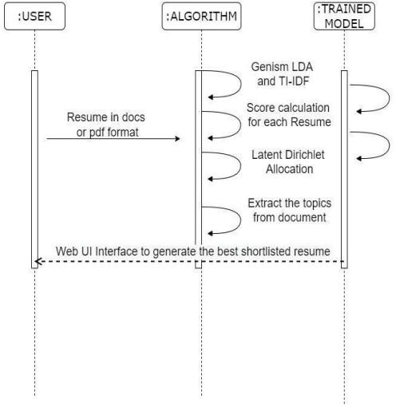
SEQUENCE DIAGRAM
These are other kinds of interaction-based diagrams that show how all the operations are carried out. They capture the context of collaborations between objects and processes.

Figure 4 : Sequence Diagram

REQUIREMENT SPECIFICATION
    - HARDWARE REQUIREMENTS
      - Processor : Pentium Dual Core 2.00GHZ
      - Hard disk : 120 GB
      - RAM : 2GB (minimum)
      - Keyboard :110 keys enhanced



3.3.2 SOFTWARE REQUIREMENTS
- Operating system : Windows7 (with service pack 1), 8, 8.1 and 10
- IDE : Anaconda
- Language : Python



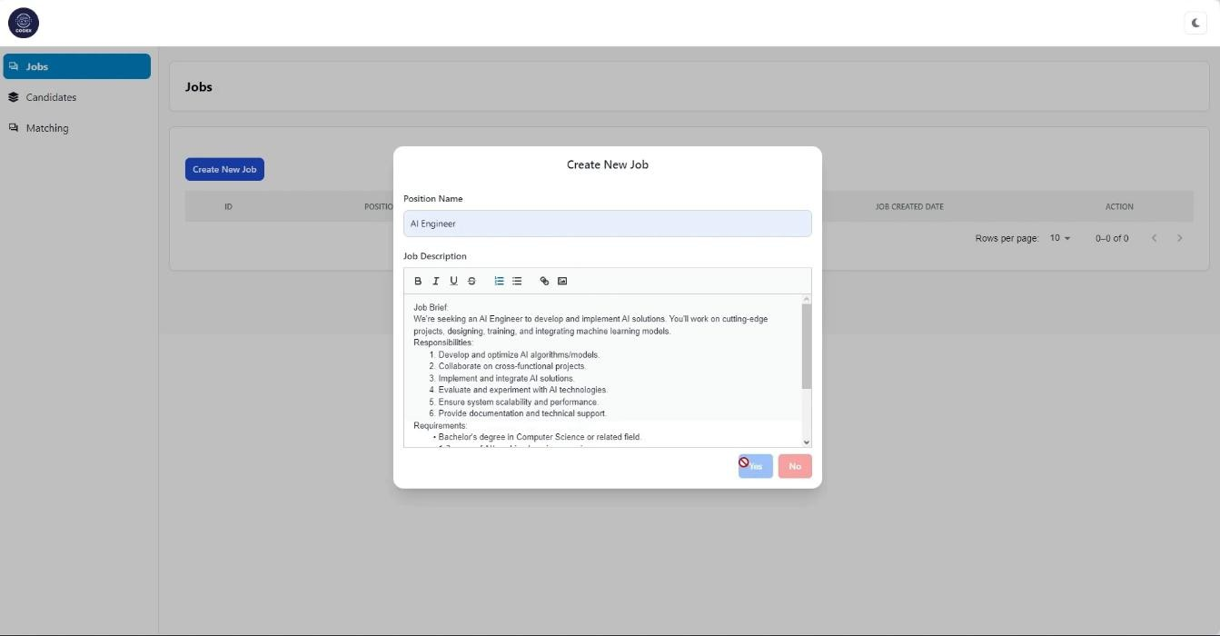
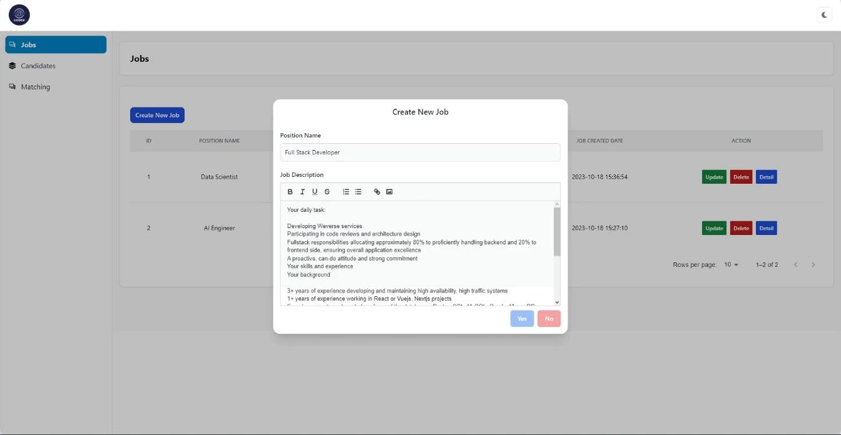
CHAPTER 4 IMPLEMENTATION AND RESULT

Snap Shots of Result:

Figure 5 : Creating a Position for a Candidate



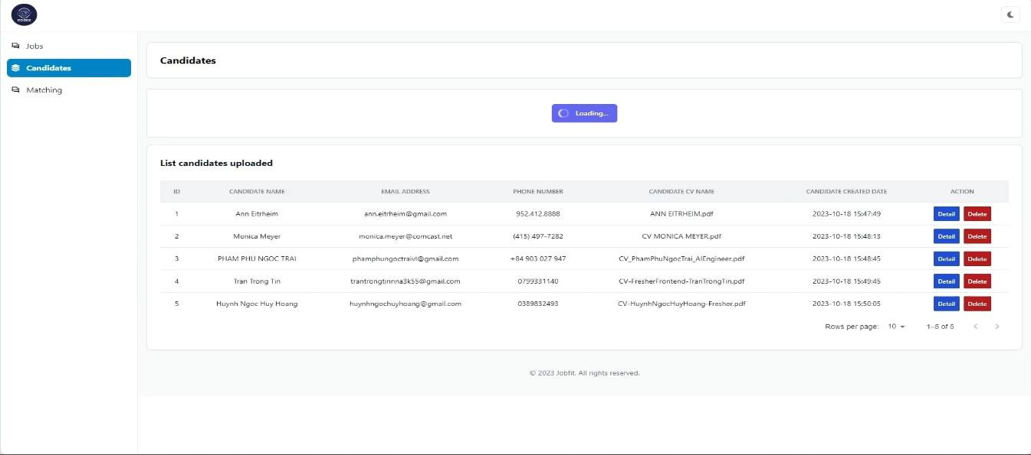
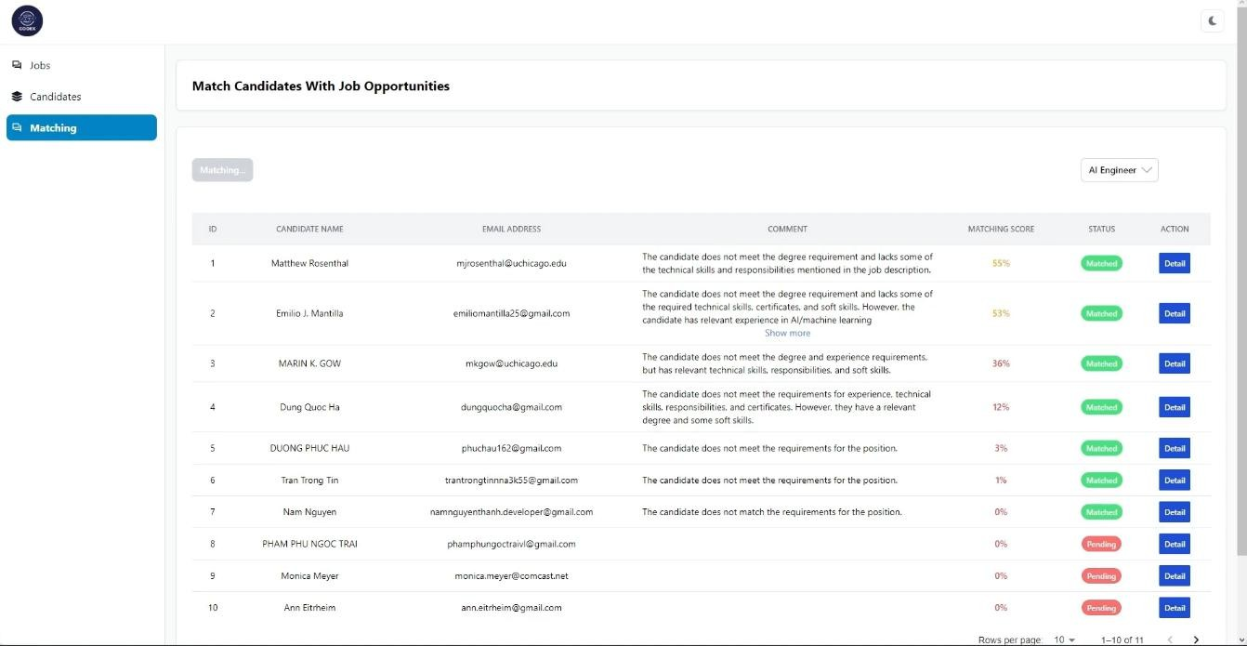

Figure 6 : Uploading the resumes

Figure 7 : Matching the candidates for AI Engineer



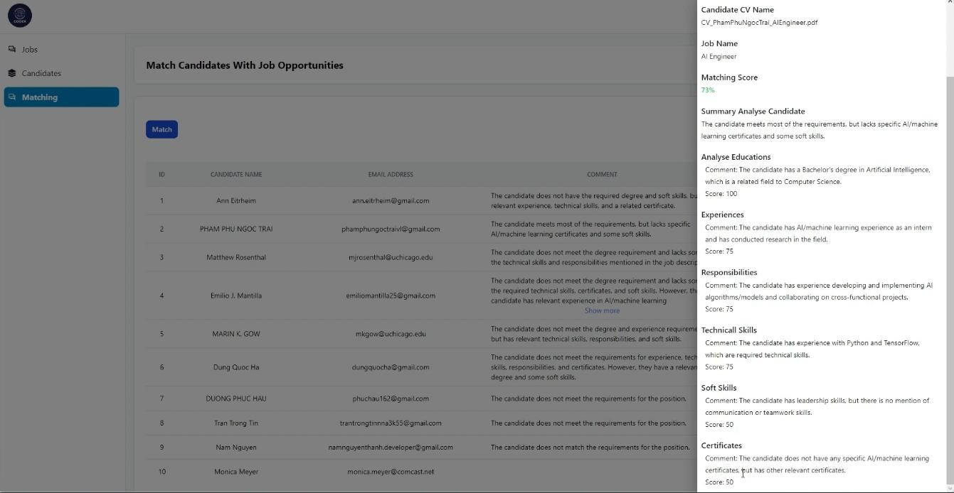

Figure 8 : Analyzing the eligibility criteria in different aspects

GitHub Link for Code:

Repository : https://github.com/Rahul18877/AICTE_Internship_FEB 2025

Code : https://github.com/Rahul18877/AICTE_Internship_FEB 2025.git



CHAPTER 5 DISCUSSION AND CONCLUSION

FUTURE WORK

Provide suggestions for improving the model or addressing any unresolved issues in future work.

CONCLUSION

Our algorithm was successfully able to screen and shortlist the best candidates with the help of NLP. Highly accurate results were obtained by using Latent Dirichlet Allocation to display the best-shortlisted resume on Web Ui. The web application was successfully able to order the resumes, by intelligently reading job descriptions as input and comparing the resumes which fall into the category of given Job Descriptions. The organization receives a large number of applications for each employment opening. Finding the right candidate's application from a sea of resumes is a time-consuming endeavor for any company these days. The classification of a candidate's resume is a laborious, time-consuming, and resource-intensive process. To address this problem, we created an automated machine learning-based algorithm that recommends acceptable applicant resumes to HR based on the job description provided. The suggested methodology had two stages: first, it classified resumes into various groups. Second, it suggests resumes based on their resemblance to the job description. If an industry produces a high number of resumes, the proposed approach can be used to create an Industry-specific model. By engaging domain experts such as HR professionals, a more accurate model may be built, and HR professionals' feedback can be used to iteratively enhance the model. The results from the model are encouraging. The resume classifier application is successful in automating the manual task of project allocation to the new recruits of the organization based on the interests, work experience, and expertise mentioned by the candidate in the profile. The Resume Screening System replaces ineffective manual screening, ensuring that no candidate is overlooked. The need for efficient and effective resume screening is at the heart of every excellent recruitment



strategy. The system will be able to accept or reject a job applicant based on two factors: the company's requirements must match the skills listed in the applicant's resume, and the test evaluation will be based on the applicant's skills, ensuring that the resumes uploaded by the applicant are genuine and the applicant is truly knowledgeable about the skills. Using NLP(Natural Language Processing) and ML(Machine Learning) to rank the resumes according to the given constraint, this intelligent system ranks the resume of any format according to the given constraints or the following requirement provided by the client company. We will basically take the bulk of input resume from the client company and that client company will also provide the requirement and the constraints according to which the resume should be ranked by our system. Besides the information provided by the resume, we are going to read the candidate's social profiles (like Linkedin, GitHub, etc.) which will give us more genuine information about that candidate. The application automates the task of project allocation, thereby eliminating the tedious and redundant affair of opening and analyzing the resumes manually by the HR team of the organization.

FUTURE ENHANCEMENTS

The application can be extended further to other domains like Telecom, Healthcare, E-commerce, and public sector jobs. We also wish to put into effect and present a smart evaluation in the consistent database to survey with the present models. Efforts can be made to explore whether it is possible to identify in advance what lists might be ranked worse than the current baseline and to investigate whether there is another way to transform word embeddings into document embeddings, such as using doc2vec, that could have a greater impact on LTR results. Another area we would want to focus on is ranking the resumes of people in different languages. Be it Dutch, German, French, or Hindi, we want to explore further ways to analyze and operate our model on major languages of the world.



REFERENCES
- Rajath V; Riza Tanaz Fareed; SharadadeviKaganurmath," Resume Classification And Ranking Using KNN And Cosine Similarity", international JOURNAL OF ENGINEERING RESEARCH & TECHNOLOGY, Volume 10, Issue 08,
AUGUST 2021

- Jitendra Purohit; Aditya Bagwe; Rishabh Mehta; OjaswiniMangaonkar; Elizabeth George, "Natural Language Processing based Jaro-The Interviewing Chatbot", 2019 3rd International Conference on Computing Methodologies and Communication (ICCMC), August 2019
- Tejaswini K; Umadevi V; Shashank M Kadiwal; Sanjay Revanna," Design and Development of Machine Learning based Resume Ranking System", Global Transitions Proceedings, October 2021

- Pradeep Kumar Roy; Sarabjeet Singh Chowdhary; Rocky Bhatia," A Machine Learning approach for automation of Resume Recommendation system",
Procedia Computer Science Volume 167, Pages 2318-2327, 2020
- AbeerZaroor, Mohammed Maree; Muath Sabha," A Hybrid Approach to Conceptual Classification and Ranking of Resumes and Their Corresponding Job Post", Smart Innovation, Systems and Technologies book series (SIST, volume 72), 2017

- [6] Garima Bhardwaj, S. Vikram Singh, Vinay Kumar," An Empirical Study of Artificial Intelligence and its Impact on Human Resource Functions", International Conference on Computation, Automation and Knowledge Management (ICCAKM), 2020

- Anushka Sharma; Smiti Singhal; Dhara Ajudia," Intelligent Recruitment System Using NLP", International Conference on Artificial Intelligence and Machine Vision (AIMV), 2021

- Yong Luo; Huaizheng Zhang: Yongjie Wang; Yonggang Wen; Xinwen Zhang," ResumeNet: A Learning-Based Framework for Automatic Resume Quality Assessment", 2018 IEEE International Conference on Data Mining (ICDM),
December 2018

- Mujtaba, Dena F., and Nihar R. Mahapatra. "Ethical Considerations in Al-Based Recruitment." 2019 IEEE International Symposium on Technology and Society (ISTAS), IEEE, 2019.

- Fahad, SK Ahmed, and Abdul Samad Ebrahim Yahya. "Inflectional review of deep learning on natural language processing." 2018 International Conference on Smart Computing and Electronic Enterprise (ICSEE). IEEE, 2018.



- Ming-Hsuan Yang, David J. Kriegman, Narendra Ahuja, “Detecting Faces in Images: A Survey”, IEEE Transactions on Pattern Analysis and Machine Intelligence, Volume. 24, No. 1, 2002.

